EXAPLES

--ΥΠΟΛΟΓΙΣΜΟΣ TOU ΑΘΡΟΙΣΜΑΤΟΣ ΟΛΩΝ ΤΩΝ ΕΠΙΣΟΔΕΙΩΝ ΤΩΝ ΣΕΙΡΩΝ

SELECT SUM (episodes)

FROM series;

--EITE Category να είναι Guns

--EITE να έχουν pano apo 5 season

SELECT *

FROM series

WHERE category=”Guns” OR seasons>5;

--To description να περιέχει το Guns

SELECT *

FROM series

WHERE description LIKE”%Guns%” ;

users (id,username,password,role,created_ad)

favorite_movies(movieid,userid)

movies(movieid,moviename,duration,description,year,category)

--ΤΑ MOVIENAME ΤΑΙΝΙΩΝ TO DESCRIPTION KAI TΗN XRONIA TON ΑΓΑΠΗΜΕΝΩΝ ΤΑΙΝΙΩΝ ΤΟΥ ΧΡΗΣΤΗ ME USERNAME “nikos”

SELECT moviename,description, movies.year

FROM movies,favorite_movies,users

WHERE movie.MovieId= favorite_movies.MovieId AND users.userid= favorite_movies.userid AND username=”nikos”;

--ΝΑ ΕΜΦΑΝΙΣΤΟΥΝ ΤΑ ΟΝΟΜΑΤΑ ΤΩΝ INSTRUCTORS OI ΟΠΟΙΟΙ ΕΙΝΑΙ ΣΤΟ DEPARTMENT ME ONOMA “Comp.Sci” (instructor)

SELECT name,

FROM instructor

WHERE dept_name=”Comp.Sci”

--ΝΑ ΕΜΦΑΝΙΣΤΟΥΝ O ΜΕΣΟΣ ΜΙΣΘΟΣ ΤΩΝ INSTRUCTORS OI ΟΠΟΙΟΙ ΕΙΝΑΙ ΣΤΟ DEPARTMENT ME ONOMA “Comp.Sci” (instructor)

SELECT AVG(salary),

FROM instructor

WHERE dept_name=”Comp.Sci”

----ΝΑ ΕΜΦΑΝΙΣΤΟΥΝ ΤΟ ΠΛΗΘΟΣ ΤΩΝ ΜΑΘΗΤΩΝ ΠΟΥ ΑΝΙΚΟΥΝ ΣΤΟ“Comp.Sci” SELECT COUNT(ID)

FROM instructor

WHERE dept_name=”Comp.Sci”

--GROUP BY

SELECT *

FROM instructor

GROUP BY dept_name

--ΜΑΖΕΒΩ ΤΙΣ ΕΓΓΡΑΦΕΣ ΣΕ ΥΠΟΣΥΝΟΛΑ ΜΕ ΤΟ DEPT_NAME KAI ΜΕΤΡΑΩ ΜΕΣΟ ΤΟΥ COUNT(INT) ΠΟΣΕΣ ΕΓΓΡΑΦΕΣ ΥΠΑΡΧΟΥΝ

SELECT dept_name, COUNT (ID),

FROM instructor,

GROUP BY dept_name;

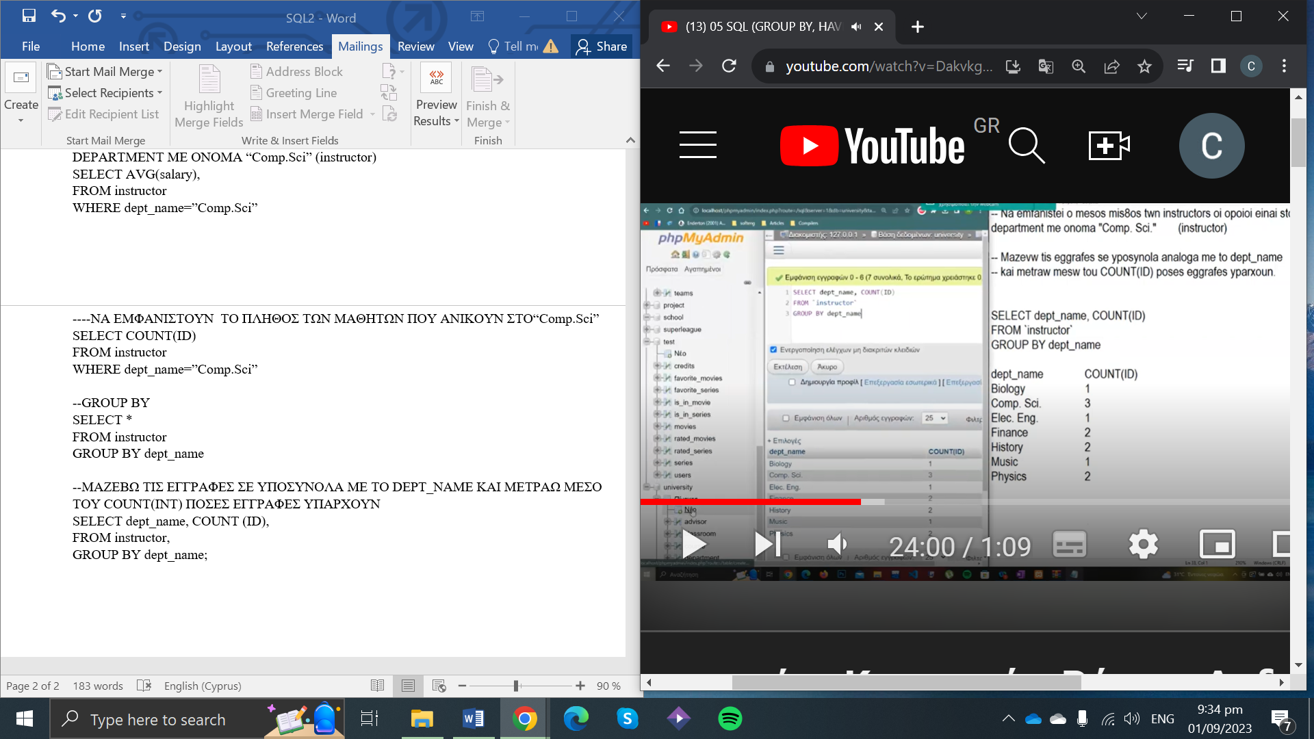

--ΘΕΛΩ ΝΑ ΥΠΟΛΟΓΙΣΩ ΤΟ ΜΕΣΟ ΟΡΟ ΑΠΟ CREDITS PΟΥ ΕΧΟΥΝ ΟΙ ΜΑΘΗΤΕΣ ΚΑΘΕ ΜΑΘΗΜΑΤΟΣ

Dept_name Mesos oros

Comp.Sci 78

Physics 34

SELECT dept_name,AVG(tot_cred)

FROM student

GROUP BY dept_name;

--ΤΑΞΙΝΟΜΗΣΗ απο μεγαλυτερο στο μικροτερο

SELECT dept_name,AVG(tot_cred)

FROM student

GROUP BY dept_name

ORDER BY AVG(tot_cred) DESC

--HAVING(ΩΤΑΝ ΧΡΗΣΙΜΟΠΟΙΩ ΣΗΝΑΡΤΗΣΕΙΣ Ή GROUP BY ANTI WHERE)

SELECT dept_name,AVG(tot_cred)

FROM student

GROUP BY dept_name

HAVING AVG(tot_cred)>75

ORDER BY AVG(tot_cred) DESC

--ΝΑ ΕΜΦΑΝΙΣΕΙΣ ΤΑ ΟΝΟΜΑΤΑ ΤΩΝ DEPARTMENTS ΠΟΥ ΕΧΟΥΝ ΤΟΥΛΑΧΙΣΤΩΝ 2 ΜΑΘΗΤΕΣ

SELECT dept_name

FROM student

GROUP BY dept_name

HAVING COUNT(id)>=2

ORDER BY dept name;

--ΤΑ ΟΝΟΜΑΤΑ KAI TA DEPT_NAME ΤΩΝ ΜΑΘΗΤΩΝ ΟΙ ΟΠΟΙΟΙ ΕΙΝΑΙ ΕΙΤΕ ΣΤΟ HISTORY EITE STO MUSIC EITE STO PHYSICS EITE STO FINANCE

1st way

SELECT name,dept_name

FROM student

WHERE dept_name IN(“History”,” MUSIC”,”PHYSICS”,”FINANCE”)

--ΤΑ ΟΝΟΜΑΤΑ KAI TA DEPT_NAME ΤΩΝ ΜΑΘΗΤΩΝ ΟΙ ΟΠΟΙΟΙ ANIKOYN SE DEPARTMENTS POU EXOUN TULAXISTON 2 MA8HTES

SELECT name,dept_name

FROM student

WHERE dept_name IN(

SELECT dept_name

FROM student

GROUP BY dept_name

HAVING COUNT(id)>=2

)

--TA ONOMATA TON MA8HTON OI OPIOI ANHKOUN SE DEPARTMENTS ME AVG(tot_cred)<80

SELECT name,dept_name

FROM student

WHERE dept_name IN(

SELECT dept_name

FROM student

HAVING AVG(tot_cred)<80

)

--TA ONOMATA TON instructors OI OPIOI ANHKOUN SE DEPARTMENTS ME AVG(tot_cred)<75 TVN MA8HTON

--The ypologiso prota ta onomata me meso oro credits mikrotero tou 75 kai meta tha ta epistrepso mesa sto IN gia na ta pari to query

Otan epistrefo ta apotelesmata,DEN ME NIAZEI apo pio pinaka ta pira.Apla me nazi na einai mesa sto IN

SELECT name

FROM instructor

WHERE dept_name IN(

SELECT dept_name

FROM student

GROUP by dept_name

HAVING AVG(tot_cred)<75

)